

Blood Bank Pre-Implementation Data Validation, Mapping, and Conversion
LR*5.2*335
Installation and User Guide

January 2009

Department of Veterans Affairs
Office of Enterprise Development
This page intentionally left blank.

Revision History
Date | Revision | Description | Author
1/31/06 | 1.0 | Initial Release | BBM team
2/14/07 | 2.0 | Updated per 025 VistA MR 041906: included instructions for using the Recommended Validation Method and for displaying Antibody Identified Free-Text Comments and the Transfusion Reactions. Changed page numbering so that Introduction is on Page 1. Inserted introduction to Verifying the Conversion. | BBM team
3/19/08 | 3.0 | - Changed description of version 1.0 revision history to Initial Release.  - Additional text added in the section entitled “Execute the DCL Command Procedure.  - Text changed in items 1 through 5 of the section entitled “Retrieve Excel Files from the VBECS System”.  - Added details on the logon sequence for the EXECUTE DCL process.  - Added details to the execution steps for the EXECUTE DCL process.  - Added details to the instructions for retrieving the EXCEL Files.  - Corrected references to the PATIENT (#2) file Internal Entry Number from DUZ to DFN.  - Corrected references to the columns in the Recommended Validation Method spreadsheet.  - Revised instructions for how to move the Excel files from VBECS to a local computer.  - Changed the dtsrun instructions to lower case. | BBM team
1/30/09 | 4.0 | Updated guide to address comments from Clinical Product Support (CPS) review:  Global: Defined first use of each acronym.  Cover page: Added the patch name, date of release, and changed organization to Office of Enterprise Development.  Orientation: Added Prerequisites section.  How this Installation and User Guide is Organized: Added National Support telephone number.  Using the Software: Added Target Audience section.  Removed all occurrences of patient sensitive information.  Post Installation Procedure: added instructions and Figure 22 to disable and enable VBECS FTP service for system security.  Added footer to the back side of the cover page.  Added an explanation to the Retrieve Excel Files section that DUZ and DFN are used interchangeably in the Excel files and in this document.  Added further information on the source of the LRDFN listed in the description of the Data Comparison File.  Change “shows as stopped” to “is no longer stopped” in Enable FTP Service for Production Account Conversion  Renamed figure 24 in Enable FTP Service for Production Account Conversion  Renamed figure 25 in Enable FTP Service for Production Account Conversion  Global: Referenced all figures and tables in the document  Exit the VBECS System: changed the sentence after Figure 7 to a new step (Step 2). | BBM team
This page intentionally left blank.

Table of Contents

Revision History i
Introduction 1
Related Manuals and Materials 1
Orientation 3
Prerequisites 3
Application Architecture 3
How This Installation and User Guide Is Organized 3
Customer Support 4
Problems? 4
Using the Software 5
Target Audience 5
Software Basics 5
Accessing the System 5
Log Into the VBECS System 5
Log Into VistA 8
Exit the VBECS System 10
Exit VistA 11
Tools 13
Digital Equipment Corporation’s Digital Command Language 13
Microsoft Excel 13
Microsoft SQL Server Enterprise Manager 13
VA FileMan 13
Installation Procedure 13
Install the LR*5.2*335 KIDS build 13
Install the DCL Command Procedure 13
Install the VBECS Data Conversion Data Transformation Services Package 14
Execute the DCL (Digital Command Language) Command Procedure 14
Execute the DTS (Data Transformation Services) Package 14
Retrieve Excel Files from the VBECS System 15
Verifying the Conversion 19
Validate the Data 19
Verify Antibodies 26
Verify Antigens 27
Verify Transfusion Reaction Type 28
Post-Installation Procedure 29
Disable FTP Service after Test Account Conversion 29
Enable FTP Service for Production Account Conversion 30
Remove FTP Service 32
Known Defects and Anomalies 37
Glossary 39
Appendices 41
Appendix A: Example of C:\DBConv\DTS Folder 41
Appendix B: Example of DCL Command Procedure 43
Appendix C: Example of DTSRUN 45
Appendix D: Database Table Information 49
Appendix E: Example of C:\DBConv Excel File Location 55
Index 57

Introduction
The purpose of the VBECS database conversion is to transfer clinically and historically relevant patient information and selected patient-related data fields from the Veterans Health Information Systems and Technology Architecture (VistA) Blood Bank database to the VistA Blood Establishment Computer Software (VBECS). After the pre-implementation data validation, mapping, and conversion process is complete, the VBECS data conversion process will gather the patient data from VistA and insert the information in the appropriate VBECS tables.

Related Manuals and Materials
- Blood Bank Pre-Implementation Data Validation, Mapping, and Conversion ADPAC Guide
- Laboratory Blood Bank User Manual (VistA)
- VBECS Data Conversion Recommended Validation Method
This page intentionally left blank.

Orientation

Prerequisites
The VBECS data conversion requires that certain conditions exist before the conversion begins.
- VistA Blood Bank Patch LR*5.2*335 must be installed. Refer to the Blood Bank Pre-Implementation Data Validation, Mapping, and Conversion ADPAC Guide for guidance on the installation and operation of the data extraction.
- The VBECS servers must be installed and configured. Refer to the VistA Blood Establishment Computer Software (VBECS) Installation Guide for guidance on the installation and configuration of the servers.

Application Architecture
The VBECS data conversion is accomplished in three steps:
- Data extraction from VistA will use options installed in VistA Blood Bank Patch LR*5.2*335. Refer to Blood Bank Pre-Implementation Data Validation, Mapping, and Conversion ADPAC Guide for guidance on the installation and operation of the data extraction.
- The transfer of extracted data from VistA to VBECS will use a Digital Command Language (DCL) command procedure loaded during the conversion installation.
- The importation of data to VBECS will use a Data Transformation Services (DTS) package installed during the VBECS installation process.

The VistA application is the existing M-based Blood Bank software package in use at Department of Veterans Affairs (VA) Medical Centers. The VBECS system is the hardware and software package being deployed to replace the existing VistA application.
The screen captures in this manual are provided as examples only. Your screens may vary.

How This Installation and User Guide Is Organized
This guide provides information on the installation and operation of the VBECS data conversion. These sections cover the requirements, installation, and operation of the VBECS database conversion software:
- Customer Support: Whom to contact for support and assistance during the installation and operation of the data conversion software. National support is available from the National Support system (888-596-4357).
- Using the Software: Steps for accessing the VistA and VBECS systems.
- Tools: Software tools used during the installation and execution of the database conversion software. The user must be familiar with these packages to complete the required tasks.
- Process: Steps involved in the installation and execution of the database conversion software.

Customer Support

Problems?
Contact your Laboratory Automated Data Processing Application Coordinator (ADPAC), Information Resource Management (IRM), and the Implementation Team for training, support during installation, and assistance with problem resolution. Screen captures of errors will speed problem resolution.

Using the Software

Target Audience
This manual is intended for use by the personnel responsible for running the database conversion. The person or persons must:
- Be assigned the VBEC MAIN menu. Refer to the Conversion Checklist section on page 3 of the Blood Bank Pre-Implementation Data Validation, Mapping, and Conversion ADPAC Guide for the installation and placement of the VBEC MAIN MENU.
- Have VMS level access.
- Have Administrator access to the VBECS system.
If a team is assembled, the members of the team must collectively have the access listed above.

Software Basics
The user installing and executing the conversion software must:
- Understand basic operations and commands for:
- DCL
- DOS
- SQL Enterprise Manager
- VA FileMan Inquire option
- Be familiar with the process and procedures involved when installing a VistA patch.

Accessing the System

Log Into the VBECS System
This is the process for logging onto the VBECS server. The VBECS application, server, and system are separate entities. The application consists of the options and functions used by blood bank personnel. The server contains the software that maintains the connection with the user, the database, and the existing VistA system. The system comprises the physical hardware, the application, and the server.
To access the VBECS server through Remote Desktop Connection in Windows XP:
- Click Start, Programs, Accessories, Communications, Remote Desktop Connection on the Windows desktop.
- Enter the name of the VBECS server (Figure 1).
Figure 1: Remote Desktop Connection
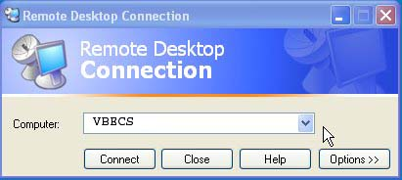

Read and click OK to acknowledge the security warning.
Enter your user name and password at the logon screen and click OK (Figure 2).
Figure 2: Windows Logon Screen
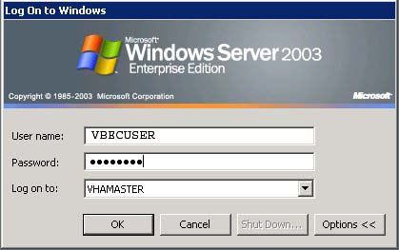
Click Start, Run from on the Windows desktop (Figure 3).
Figure 3: Windows Desktop on the Remote Machine
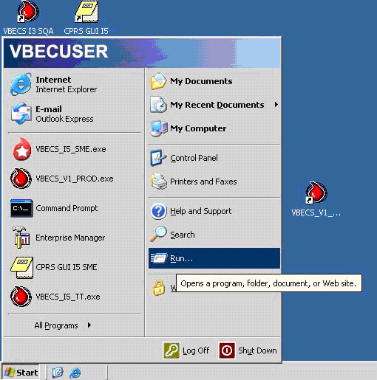

Enter cmd at the Open prompt. Click OK (Figure 4), resulting in Figure 5.
Figure 4: Entering Command Mode on the Remote System
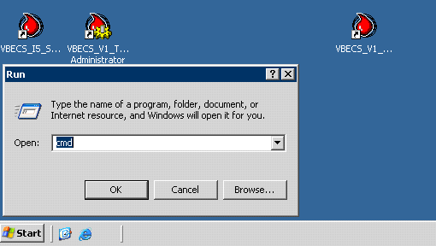
Figure 5: Entering Command Mode on the Remote System
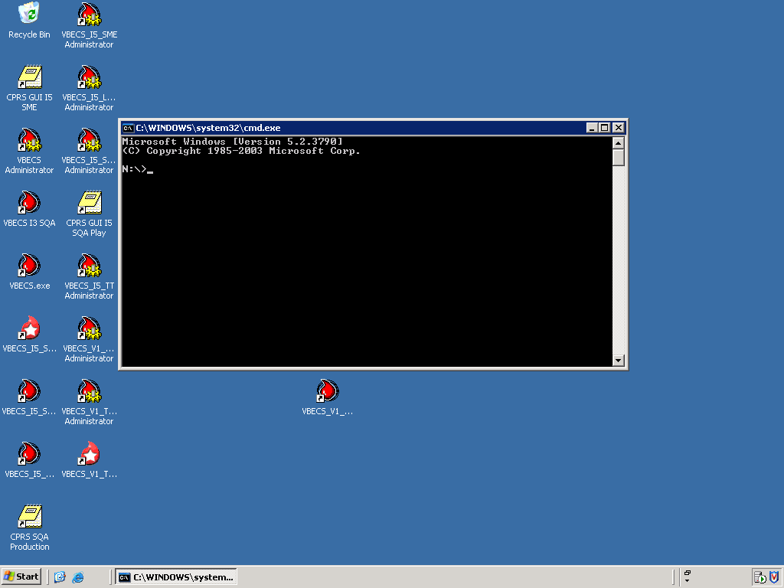
Refer to the Execute DTS Package section of this guide for additional instructions for executing the data conversion.

Log Into VistA
The VistA system is accessed through a terminal emulation program such as KEA or SmartTerm. See your local IRM for the details to access VistA, or if problems are encountered during logon. When you log onto VistA, you will see a screen similar to Figure 6. Refer to the Conversion Checklist section on page 3 of the Blood Bank Pre-Implementation Data Validation, Mapping, and Conversion ADPAC Guide for the installation and placement of the VBEC MAIN MENU.
Figure 6: Example of a Logon Screen
Username: DHCP

***************************************************************************
* Access is granted to this system for OFFICIAL PURPOSES ONLY. *
* Misuse of this system or information contained in this system is a *
* Federal Crime and will be prosecuted to the fullest extent of the law *
* Auditors monitor and record the use of this system; by using this *
* system you consent to such monitoring. *
***************************************************************************

**VISTA USERS: For computer related work orders, your first point of **
contact is your Service ADP Coordinator (ADPAC). Please check with them
before contacting IRMS.

**************************************************************************

Volume set: ROU:123A04 UCI: VAH Device: TNA5842: (10.6.193.21/2507)

ACCESS CODE: ***********
VERIFY CODE: ***********

Good afternoon VISTAUSER,ONE
You last signed on May 03, 2005 at 07:57
You have 3 new messages. (3 in the 'IN' basket)
(Last arrival: 05/10/05@07:31)

Enter '^NML' to read your new messages.
Select TERMINAL TYPE NAME: C-VT102//
DEC VT102 Terminal with Advanced Options
****WARNING: E-MAIL IS LIMITED TO OFFICIAL VA BUSINESS ONLY****
MISUSE AND/OR ABUSE MAY RESULT IN DISCIPLINARY ACTION
AND/OR LOSS OF ACCESS TO MAILMAN PRIVILEGES.

VA MailMan 8.0 service for VISTAUSER.ONE@YOURSITE.MED.VA.GOV
You last used MailMan: 05/03/05@07:57
Your current banner: Good Morning.
You have 3 new messages.

NML New Messages and Responses
RML Read/Manage Messages
SML Send a Message
Query/Search for Messages
AML Become a Surrogate (SHARED,MAIL or Other)
Personal Preferences ...
Other MailMan Functions ...
Help (User/Group Info., etc.) ...
MESSAGES OVER 2 YEARS OLD

Select MailMan Menu Option:

Exit the VBECS System
To log off the VBECS server (not the VBECS application):
- Click Start and Log Off from the Windows desktop (Figure 7).
Figure 7: Log Off the Remote VBECS Server
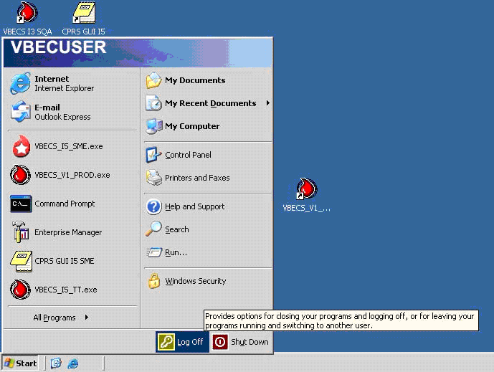
- Click Log Off at the dialog box (Figure 8). The system will log off the VBECS server and close Remote Desktop Connection (Figure 9).
Figure 8: Logoff Verification on the Remote VBECS Server
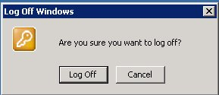
Figure 9: Logoff Window on the Remote VBECS Server
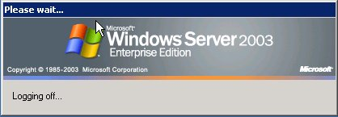

Exit VistA
You may exit VistA from any menu prompt. Enter HALT at the prompt and press the Enter key. When you log off VistA, you will see a screen similar to Figure 10.
Figure 10: Example of a Logoff Screen
VA MailMan 8.0 service for VISTAUSER.ONE@YOURSITE.MED.VA.GOV
You last used MailMan: 5/10/05@10:58
You have no new messages.

NML New Messages and Responses
RML Read/Manage Messages
SML Send a Message
Query/Search for Messages
AML Become a Surrogate (SHARED,MAIL or Other)
Personal Preferences ...
Other MailMan Functions ...
Help (User/Group Info., etc.) ...
MESSAGES OVER 2 YEARS OLD

Select MailMan Menu Option: HALT

DHCP logged out at 10-MAY-2005 14:24:01.25

This page intentionally left blank.

Tools

Digital Equipment Corporation’s Digital Command Language
DCL is the standardized command line interface used at the VMS level on the VistA system. It will be used during the installation and execution of the VBECS data conversion to execute a DCL command procedure to transfer VistA data to the VBECS system.

Microsoft Excel
Microsoft Excel is a spreadsheet program for viewing tabular data. It will be used during data validation after installation and execution of the VBECS data conversion to view data transferred to the VBECS system.

Microsoft SQL Server Enterprise Manager
Microsoft SQL Server Enterprise Manager is the primary administrative tool for Microsoft SQL Server. If necessary, it will be used during the data validation to view the contents of the SQL tables loaded during the data conversion.

VA FileMan
VA FileMan is the database management system used by VistA to identify the VMS-level directory housing text files created during the database conversion.

Installation Procedure

Install the LR*5.2*335 KIDS build

- The installation instructions for patch LR*5.2*335 are detailed in the LR*5.2*335 patch message.

Install the DCL Command Procedure
- Complete the instructions in Blood Bank Pre-Implementation Data Validation, Mapping, and Conversion ADPAC Guide.
- Use VA FileMan to access the DEFAULT DIRECTORY field (#.06) in the VBECS Site Parameters file (#6000). Record the name of the DEFAULT DIRECTORY.
- Log onto a VMS-level account.
- Copy the VBECSBATCH.COM file from the FTP distribution site to the VMS-level directory specified in the DEFAULT DIRECTORY field (#.06) of the VBECS Site Parameters file (#6000).
- Copy VBECS Data Conversion Recommended Validation Method (spreadsheet) from the FTP site to your local desktop system. This spreadsheet will be used to determine the quantity and record numbers of the records to be validated.

Install the VBECS Data Conversion Data Transformation Services Package
The VBECS Data Conversion Data Transformation Services (DTS) Package and its associated folder structure were installed during the VBECS installation. See Appendix A: Example of C:\DBConv\DTS Folder.

Execute the DCL (Digital Command Language) Command Procedure
- Log onto a VMS-level account on the VistA system where the conversion was performed.
- Enter set def at the VMS command prompt and press the Enter key.
- Enter the temporary folder name you specified in the database conversion option PRE Utilities Used prior to the Data Conversion, sub option Enter/Edit Site Parameter Data at the _Directory: and press the Enter key.
- Enter @VBECSBATCH.COM at the VMS command prompt and press the Enter key.
- When prompted, enter the IP address of the first node of the VBECS system
- When prompted, enter your domain followed by a backslash, the NT user name on the VBECS system and press the Enter key.
- When prompted, enter your NT password and press the Enter key. (The IP address and user name will echo to the local screen when entered; the password will not be visible.)
- The command procedure will test for the existence of the VBEC_FINIS.TXT file (automatically created during the conversion process), which will indicate that the VistA data extraction was completed. The system displays “File not found, pausing” if the file does not exist. The system will pause for 15 minutes before retesting for the existence of the file and will retest every 15 minutes thereafter. When the VBEC_FINIS.TXT file is created on VistA, the command file will transfer, by File Transfer Protocol (FTP), the files containing the data to be converted to the appropriate VBECS folder.
- Repeat steps 1-8 again and input the IP address of the second node of the VBECS server in step 5. This will send the files to both nodes of the VBECS cluster.

See Appendix B: Example of DCL Command ProcedureExecute the DTS (Data Transformation Services) Package
The DTS package will insert the files transferred from VistA in the VBECS tables.
- To prepare for the execution of the DTS package:
- Log onto an account on the VBECS system with Administrator privileges.
- Click Start and Run from the Windows taskbar.
- Enter cmd in the Run Window. Click OK.
- To run the conversion:
- Enter cd c:\dbconv\dts at the command prompt.
- Enter dtsrun /f conversionpackagemultidb.dts at the command prompt. Press the Enter key.

See Appendix C: Example of DTSRUN.

Retrieve Excel Files from the VBECS System
The DTS package copies the VBECS tables populated with data from VistA into Excel files. See Appendix D: Database Table Information for a list of data extracted from VBECS during the execution of the DTS package. These files contain patient sensitive data and must be handled in accordance with all local and VA information security rules.
- Log into the computer that will be used to perform the database conversion validation (this computer must have Excel installed in order to read the files). The validation should not be performed on the VBECS server.
- Click Start, My Computer on this PC.
- Type two back slashes, the I.P. address of one of the VBECS servers, a back slash, and c$ in the Address line and press the Enter key (Figure 11). This will connect you to the system where the conversion was performed. c$ is a hidden share folder and the VBECS server is shipped with this share pre-configured.
Figure 11: Example of server I.P. address
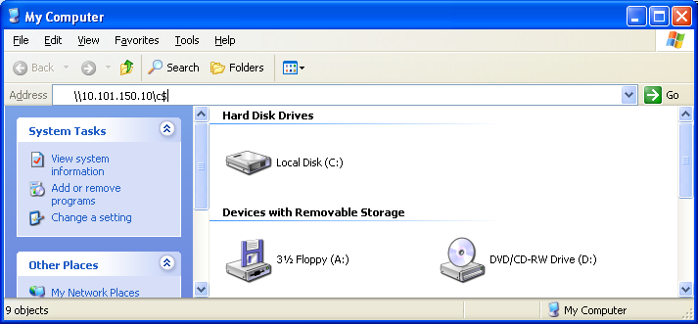

- Windows will ask for a User Name and Password to access the server if your credentials are not passed to the server. Enter your User Name with the associated password, click OK (Figure 12).
Figure 12: Example of server access window.
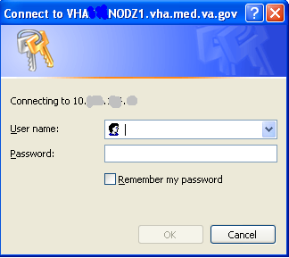

- Navigate to the DBCONV folder on the c: drive and retrieve all seven Excel files (“.XLS” extension) from the VBECS system by copying the files to a folder on your local computer. See Appendix E: Example of C:\DBConv Excel File Location.
- Open these files in Excel (Note: DFN and DUZ are used interchangeably in the Excel files and in this document.):
- Patient_Data_Report.XLS: This file contains the Patient DFN, SSN, ICN, Last Name, First Name, Middle Name, Name Suffix, DOB, Blood Type, Rh Factor, DOB check (valid/invalid date), and Sex..
- Patient_Special_Instruction_Report.XLS: This file contains the Patient DFN, Last Name, First Name, SSN, Date/Time Comment Created, and Blood Bank Comments. All converted Antigen Present and Antigen Absent data are stored in the PatientSpecialInstruction table in VBECS.
- Patient_Transfusion_Comment_Report.XLS: This file contains the Patient DFN, SSN, Last Name, First Name, and Transfusion Comment.
- Patient_Antibodies_Identified.XLS: This file contains the Patient DFN, SSN, Last Name, First Name, Antibody Type, Transfusion Requirement Text, Date/Time Created, and Transfusion Requirement Category.
- Patient_Transfusion_Data.XLS: This file contains the Patient DFN, SSN, Last Name, First Name, Date/Time Noted, and Transfusion Reaction Type.
- Patient_Test_Report.XLS: This file contains the Patient DFN, SSN, Last Name, First Name, Test Name, Results, and Test Comments.
Data_Comparison.XLS: This file will list mismatches between the data in the files from VistA and the files in VBECS after the conversion. The data listed are:
- LastNameMismatch
- FirstNameMisMatch
- MiddleNameMisMatch
- NameSuffixMisMatch
- SexMisMatch
- DOBMisMatch
- SSNMisMatch
- ICNMisMatch
- ABOMisMatch
- RHFactorMisMatch
- AntigensPresentQuantityMisMatch
- AntigensPresentCommentQuantityMisMatch
- AntigensPresentCommentLengthMisMatch
- AntigensAbsentQuantityMisMatch
- AntigensAbsentCommentQuantityMismatch
- AntigensAbsentCommentLengthMisMatch
- AntibodiesIdentifiedQuantityMisMatch
- AntibodiesIdentifiedCommentQuantityMisMatch
- AntibodiesIdentifiedLengthMisMatch
- TransfusionReactionDateQuantityMisMatch
- TransfusionReactionQuantityMisMatch
- TransfusionReactionCommentQuantityMisMatch
- TransfusionReactionCommentLengthMisMatch
- BloodBankCommentsLengthMisMatch

- Use the six files listed in step five to validate the data loaded in the VBECS system. Each file contains a series of items related to a patient’s record. Each item contains the patient’s DFN, SSN, Last Name, and First Name. Use these identifiers to reference the equivalent data in the VistA database and ensure that no discrepancies exist between the two databases. It is not necessary to validate all data. A statistically significant sample (refer to the VBECS Data Conversion Recommended Validation Method spreadsheet) will suffice.
- If errors are found during the data validation:
- Review and revise all VistA data mapping. Refer to the PRE: Utilities Used Prior to the Data Conversion section in Blood Bank Pre-Implementation Data Validation, Mapping, and Conversion ADPAC Guide for further instructions on VistA conversion options.
- Recreate the VistA data files. Refer to the CONV: Utilities Used for the Data Conversion section in the ADPAC guide for further instructions on VistA conversion options.
9) The Data_Comparison.XLS file will list discrepancies that occurred while loading the data.
shows an example of mismatched data (but does not represent all of the columns to
be listed in the spreadsheet). Three conditions are represented:
- A mismatch in the presence or absence of data (MiddleNameMisMatch column).
- A mismatch between the number of records found in VistA and the number loaded into VBECS (AntigensPresentQuantityMisMatch column).
- A mismatch between the length of a record extracted from VistA and the record loaded into VBECS (AntibodiesIdentifiedLengthMisMatch column). This file will be empty if no discrepancies were noted.

Table 1: Data Comparison File Output
LRDFN | MiddleNameMisMatch | AntigensPresent  QuantityMisMatch | AntibodiesIdentified  LengthMisMatch | TransfusionReactionQuantityMisMatch
1451 | None | 0 <VBECS--VISTA> 3 | None | None
1278 | None | None | None | 7 <VBECS--VISTA> 0
15094 | None | None | 33 <VBECS--VISTA> 0 | None
9167 | 1 <VBECS--VISTA> 0 | None | None | None

The LRDFN column is for reference only and does not indicate that the LRDFN is mismatched. Use it to determine which VistA data record is associated with the mismatch noted in the remaining columns.
If a mismatch is noted the LRDFN identifies the patient record from VistA in the LAB DATA File (#63) where the data was extracted., and the SSN from this patient record identifies the VBECS record where the data were loaded. The name of the populated column indicates the kind of mismatch; the data in that column show the mismatch. A manual comparison of the affected data is necessary to determine which data are in error. Once the point of failure is determined and a solution is found, the VistA extraction, transfer, and VBECS data load must be re-executed.
- Use the spreadsheet created in the Calculations tab of VBECS Data Conversion Recommended Validation Method to determine the number of records to be validated. Follow the instructions in VBECS Data Conversion Recommended Validation Method to complete the validation.
- Rerun the data conversion if discrepancies are found during the validation.

Verifying the Conversion
The verification of VistA records transferred to VBECS is an integral step in the VBECS validation process. Instructions for using a statistical sampling method are included in this guide as a starting point for validating a successful database conversion. Each site must evaluate the VBECS Data Conversion Recommended Validation Method for use and recognize that further validation will be necessary in certain situations.

Validate the Data
- Open VBECS Data Conversion Recommended Validation Method (Excel workbook).
- If the “Macros are disabled because the security level is set to High” message appears, click Tools, Macro, Security. Select the Security Level tab. Click the Medium radio button. Click OK and close the workbook. Reopen the workbook and click Enable Macros in the Security Warning dialog box. Keep the workbook open.
- Select the Calculations worksheet. The Calculations worksheet identifies a random set of numbers used to inspect the accuracy of the VistA-to-VBECS data conversion.
- Open Patient_Data_Report (Excel workbook). Press Ctrl + End to view the last entry. The row number of the last entry in the first column represents the total number of records converted (lot size) (Figure 13).
Figure 13: Example of Last Entry in Patient_Data_Report
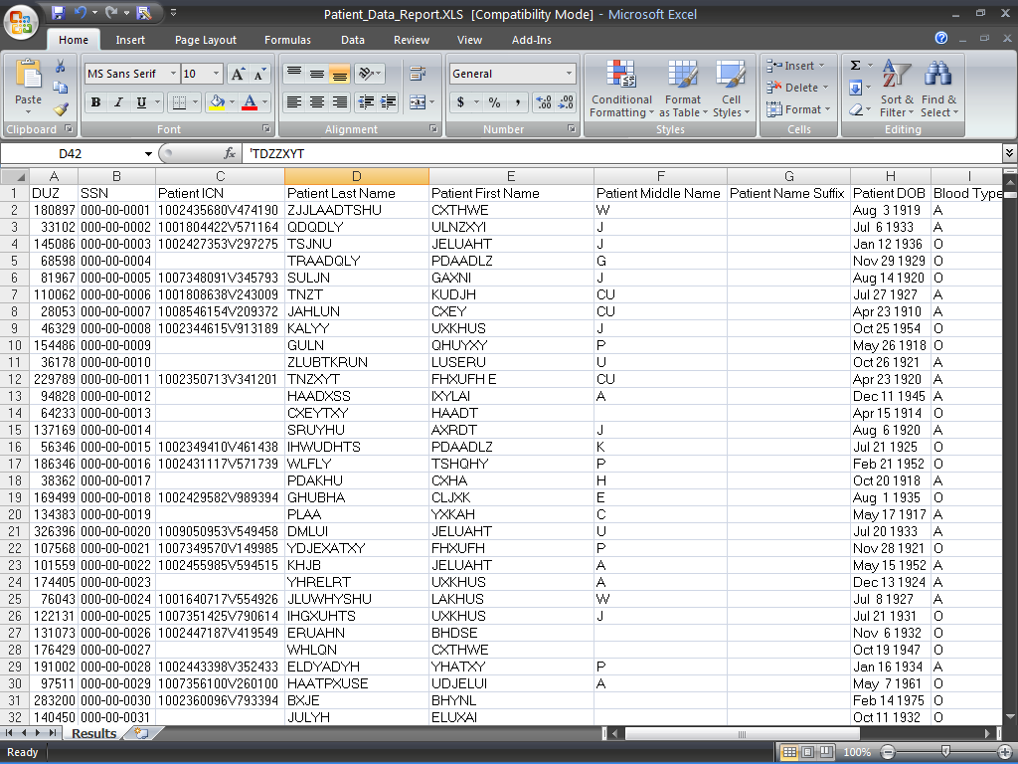
- Return to VBECS Data Conversion Recommended Validation Method.
- Enter the lot size in Cell C4 (highlighted in yellow; default is “1,234”). Press the Enter key to generate the number of samples to be inspected (Cell C5, highlighted in blue) and random patient data report row numbers (Column E) (Figure 14).
Figure 14: Example of Total Number of Records Converted (Lot Size) Entered in Cell C4
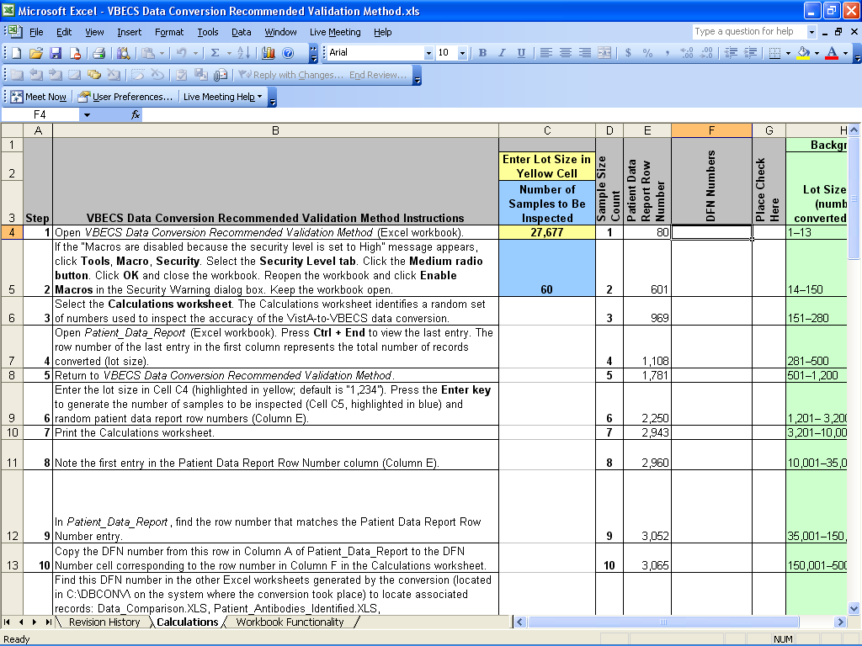
- Print the Calculations worksheet.
- Note the first entry in the Patient Data Report Row Number column (Column E) (Figure 15).
Figure 15: First Entry in the Patient Data Report Row Number Column
- In Patient_Data_Report, find the row number that matches the Patient Data Report Row Number entry (Figure 16).
Figure 16: Row Number in Patient_Data_Report Matching Entry in the Patient Data Report Row Number Column
- Copy the DFN number from this row in Column A of Patient_Data_Report to the DFN Number cell corresponding to the row number in Column F in the Calculations worksheet (Figure 17).
Figure 17: DFN Number Copied from Patient_Data_Report to Calculations Worksheet
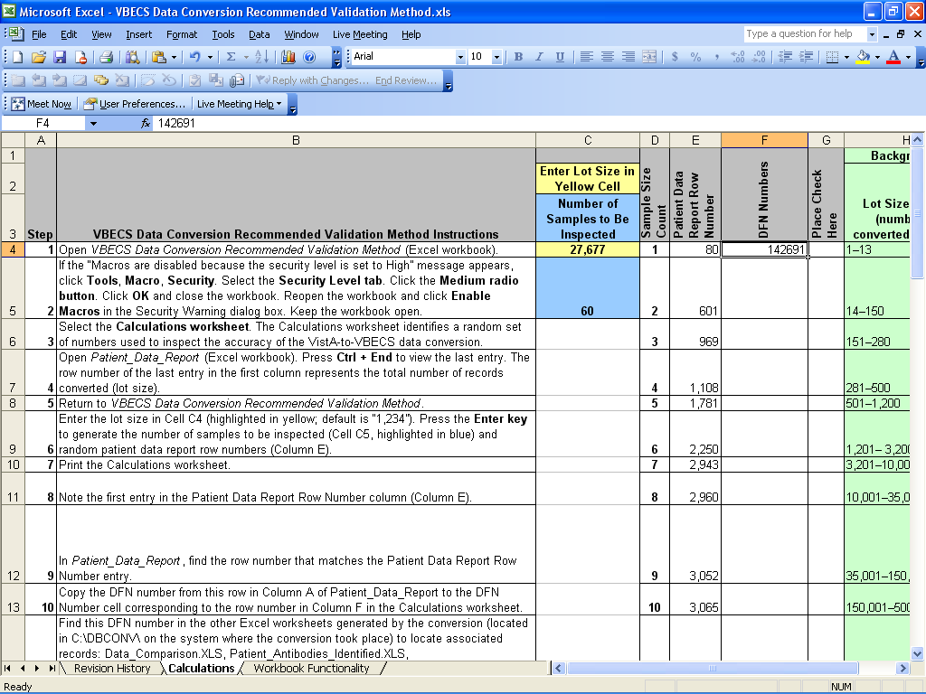
- Find this DFN number in the other Excel worksheets generated by the conversion (located in C:\DBCONV\ on the system where the conversion took place). See Appendix E: Example of C:\DBConv Excel File Location to locate associated records:
- Data_Comparison.XLS
- Patient_Antibodies_Identified.XLS
- Patient_Special_Instruction_Report.XLS
- Patient_Test_Report.XLS
- Patient_Transfusion_Comment_Report.XLS
- Patient_Transfusion_Data.XLS
- Compare the converted data in the Excel worksheets with the original VistA data.
- When all data for a record are inspected and no errors found, insert a check mark in the Place Check Here column (Column G) in VBECS Data Conversion Recommended Validation Method (Figure 18).
Figure 18: Place Check Here
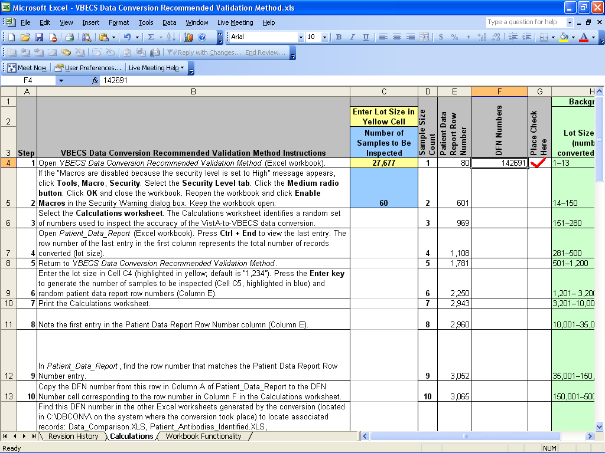
- Select the next patient data report row number from the Calculations worksheet and verify each data element. Continue until data for all rows in the Column E are inspected.
- When all records are validated and found to be correct, complete the form in Step 16 of VBECS Data Conversion Recommended Validation Method.

Verify Antibodies
The Antibodies Identified and their associated free-text comments may not display using the VistA options for deceased patients. Use the FileMan print (Figure 19) to retrieve these records individually based on the Patient DFN. User input is in bold text.
Figure 19: FileMan Print to Verify Antibodies
Select OPTION: PRINT FILE ENTRIES

OUTPUT FROM WHAT FILE: PATIENT//
SORT BY: NAME//
START WITH NAME: FIRST// TESTPATIENT,TWO
GO TO NAME: LAST// TESTPATIENT,TWO
WITHIN NAME, SORT BY:
FIRST PRINT FIELD: SSN SOCIAL SECURITY NUMBER
THEN PRINT FIELD: LABORATORY REFERENCE:ANTIBODIES IDENTIFIED:ANTIBODIES IDENTIFI
ED;"Antibodies Identified"
THEN PRINT FIELD: LABORATORY REFERENCE:ANTIBODIES IDENTIFIED:ANTIBODIES IDENTIFI
ED COMMENT;"Comment"
THEN PRINT FIELD:
Heading (S/C): PATIENT LIST//
STORE PRINT LOGIC IN TEMPLATE:
START AT PAGE: 1//
DEVICE: UCX TELNET SESSION
PATIENT LIST OCT 30,2008 14:08 PAGE 1
SOCIAL
SECURITY
NUMBER Antibodies Identified
Comment
--------------------------------------------------------------------------------

NAME: TESTPATIENT,TWO
000000034 ANTI E
ANTIBODY,public,NOS
give E negative units
warm autoantibody

Verify Antigens
The Antigens Absent and their associated free-text comments may not display using the VistA options for deceased patients. Use the FileMan print (Figure 20) to retrieve these records individually based on the Patient DFN. User input is in bold text. To find the Antigens Absent listing, replace PRESENT with ABSENT in the following example.
Figure 20: FileMan Print to Verify Antigens
Select OPTION: PRINT FILE ENTRIES

OUTPUT FROM WHAT FILE: PATIENT//
SORT BY: NAME//
START WITH NAME: FIRST// YLNAXU,CLZHT CU
GO TO NAME: LAST// YLNAXU,CLZHT CU
WITHIN NAME, SORT BY:
FIRST PRINT FIELD: SSN SOCIAL SECURITY NUMBER
THEN PRINT FIELD: LABORATORY REFERENCE:BLOOD BANK:RBC ANTIGEN PRESENT:RBC ANTIGE
N PRESENT;"RBC Antigen Present"
THEN PRINT FIELD: LABORATORY REFERENCE:BLOOD BANK:RBC ANTIGEN PRESENT:COMMENT;"Comment"
THEN PRINT FIELD:
Heading (S/C): PATIENT LIST//
STORE PRINT LOGIC IN TEMPLATE:
START AT PAGE: 1//
DEVICE: UCX TELNET SESSION
PATIENT LIST OCT 30,2008 15:12 PAGE 1
SOCIAL
SECURITY
NUMBER RBC Antigen Present
Comment
--------------------------------------------------------------------------------
NAME: TESTPATIENT,THREE
000000059
C
Fy(a)
Fy(b)
Jk(a)
Jk(b)
Le(b)
M,NOS
N
c
e
All antigens confirmed

Select OPTION:

Verify Transfusion Reaction Type
The Transfusion Reaction Type and its associated free-text comments may not display using the VistA options for deceased patients. Use the FileMan print (Figure 21) to retrieve these records individually based on the Patient DFN. User input is in bold text.
Figure 21: FileMan Print for Transfusion Reaction Type
Select OPTION: PRINT FILE ENTRIES

OUTPUT FROM WHAT FILE: PATIENT//
SORT BY: NAME// NUMBER
START WITH NUMBER: FIRST// 20
GO TO NUMBER: LAST// 20
WITHIN NUMBER, SORT BY:
FIRST PRINT FIELD: NAME
1 NAME
2 NAME COMPONENTS
CHOOSE 1-2: 1 NAME
THEN PRINT FIELD: SSN SOCIAL SECURITY NUMBER
THEN PRINT FIELD: LABORATORY REFERENCE:TRANSFUSION REACTION DATE:TRANSFUSION REACTION DATE
THEN PRINT FIELD: LABORATORY REFERENCE:TRANSFUSION REACTION DATE:TRANSFUSION REACTION TYPE
THEN PRINT FIELD: LABORATORY REFERENCE:TRANSFUSION REACTION DATE:TRANSFUSION REACTION COMMENT:TRANSFUSION REACTION COMMENT
THEN PRINT FIELD:
Heading (S/C): PATIENT LIST//
STORE PRINT LOGIC IN TEMPLATE:
START AT PAGE: 1//
DEVICE: 0;80;99999 UCX/TELNET
PATIENT LIST MAR 22,2006 17:08 PAGE 1
LABORATORY
REFERENCE:TRANSFUSION
SOCIAL REACTION
SECURITY DATE:TRANSFUSION
NAME NUMBER REACTION DATE
LABORATORY REFERENCE:TRANSFUSION REACTION DATE:TRANSFUSION REACTION TYPE
LABORATORY REFERENCE:TRANSFUSION REACTION DATE:TRANSFUSION REACTION
COMMENT:TRANSFUSION REACTION COMMENT
-----------------------------------------------------------------------

NUMBER: 20
TESTPATIENT,ONE 000003141 2960116
LEGACY
UNIT UNKNOWN
SECOND LINE
THIRD LINE

Post-Installation Procedure
For system security purposes the FTP service on the VBECS server must be disabled following the successful conversion of the VistA Test account to the VBECS Test account. The VBECS FTP service is enabled prior to converting the Production account. Following the successful conversion and validation of data in the VBECS production account the FTP service on the VBECS server is removed.

Disable FTP Service after Test Account Conversion

- Log into the first node (server) of the VBECS cluster server with administrative privileges.
- Click Start, Control Panel, Administrative Tools, Internet Information Services (IIS) Manager. The IIS console launches.
- Expand the FTP Sites node.
- Right click on VBECSFtp and click Stop (Figure 22).
Figure 22: Stop VBECSFtp
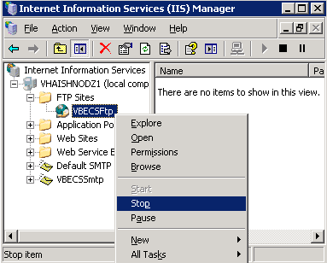

- Verify VBECSFtp shows as stopped (Figure 23).
Figure 23: VBECSFtp Services are Stopped.
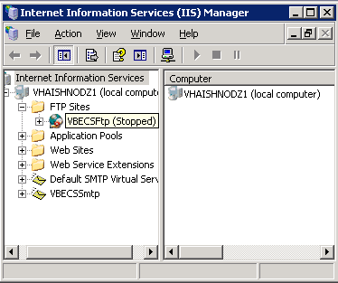

- The FTP service will now remain shut down until started again. Repeat this process on the second node (server) in the VBECS cluster.

Enable FTP Service for Production Account Conversion
- Log into the first node (server) of the VBECS cluster server with administrative privileges.
- Click Start, Control Panel, Administrative Tools, Internet Information Services (IIS) Manager. The IIS console launches.
- Expand the FTP Sites node.
- Right click on VBECSFtp and click Start (Figure 24).
Figure 24: Starting VBECSFtp Services.
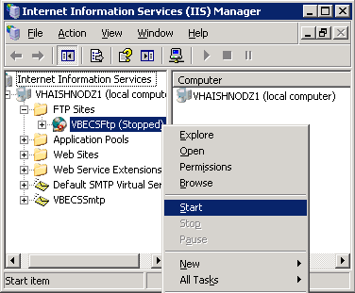

- Verify VBECSFtp is no longer stopped (Figure 25).
Figure 25: VBECSFtp Service Enabled.
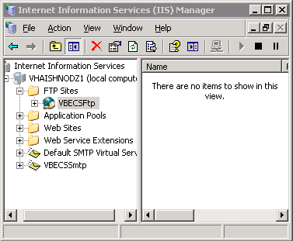

- The FTP service will now remain running until stopped or disabled. Repeat this process on the second node (server) in the VBECS cluster.

Remove FTP Service
Remove the FTP service from the VBECS server after the conversion process is successfully completed to prevent certain forms of unauthorized access to the system.
- Click Start, Control Panel.
- Double click Add or Remove Programs (Figure 26).
Figure 26: Control Panel
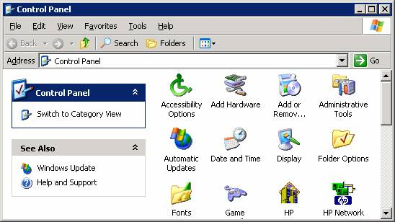
- Click Add/Remove Windows Components (Figure 27).
Figure 27: Add/Remove Windows Components
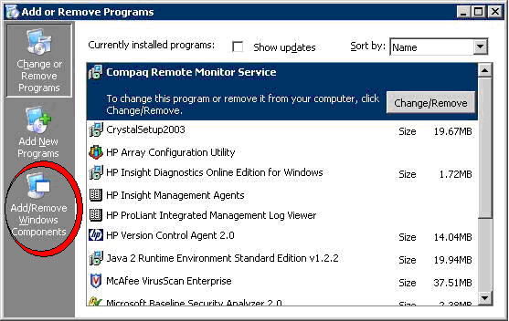
- Select Application Server and click Details (Figure 28).
Figure 28: Windows Component Wizard
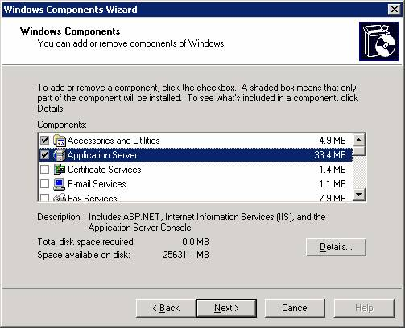
- Select Internet Information Services (IIS) and click Details (Figure 29).
Figure 29: Application Server
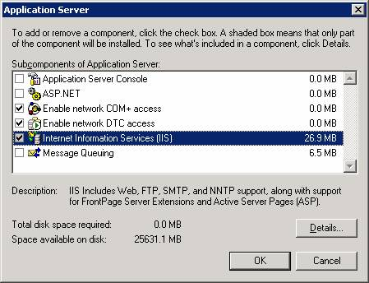
- Clear the File Transfer Protocol (FTP) Service check box and click OK (Figure 30).
Figure 30: Internet Information Services (IIS)
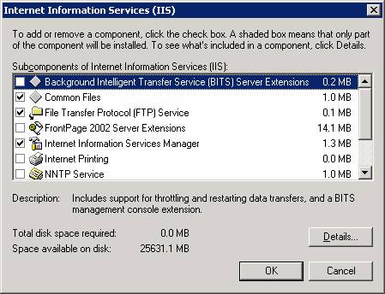
- Click OK (Figure 31).
Figure 31: Application Server
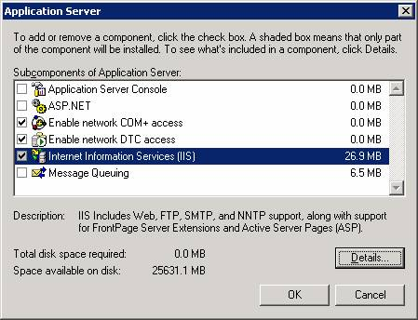

- Click Next. (Figure 32)
Figure 32: Windows Components Wizard
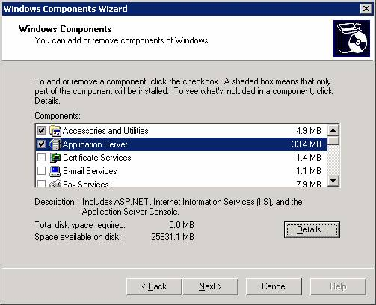
- Click Finish (Figure 33).
Figure 33: Completing the Windows Components Wizard
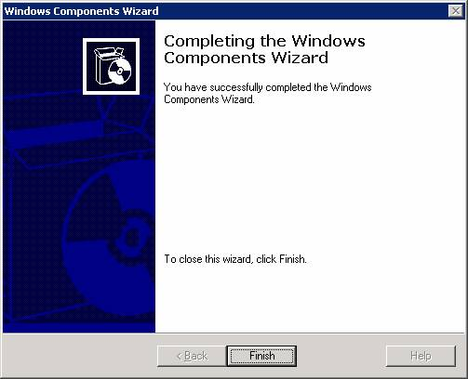
This page intentionally left blank.

Known Defects and Anomalies
None

This page intentionally left blank.

Glossary
Acronym, Term | Definition
Access Code | A field in the VistA New Person file used to uniquely identify a user on the VistA system.
ADPAC | Automated Data Processing Application Coordinator.
Antibody | A protein in the serum of some people that will react to a specific antigen on the blood cells. In the case of a red blood cell transfusion, a patient with a clinically significant (leading to a transfusion reaction and possible patient harm) identified antibody must receive only red cells that are typed and found negative for the associated antigen. Once a clinically significant antibody is identified, antigen-negative cells must always be transfused even if a current specimen no longer shows the presence of the antibody.
Antigen | A substance on the surface of a red cell that stimulates an immune response (formation of an antibody).
Checksum | A numerical representation of a routine as calculated by the CHECK^XTSUMBLD utility in VistA.
Database | A collection of data arranged for ease and speed of retrieval.
DCL | Digital Command Language.
DFN | The internal entry number of a record in the PATIENT (#2) file.
DTS | Data Transformation Services. A feature in SQL Server 2000 that provides functionality to import, export, and transform data.
DUZ | A variable name, used within VistA, assigned a numerical value internally unique to the current user.
File | Source code, data, and documentation.
FTP | File Transfer Protocol.
IA  INT | Integration Agreement.  Integer (whole number) data from -2^31 (-2,147,483,648) through 2^31 - 1 (2,147,483,647).
IP Address | An IP address (Internet Protocol address) is a unique number that devices use in order to identify and communicate with each other on a network utilizing the Internet Protocol standard.
IRM | Information Resource Management.
IT | Information Technology.
Rh | Rhesus factor.
Rhesus factor | Any of one or more genetically determined antigens usually present in the red blood cells of humans and higher animals and capable of inducing intense immunogenic reactions.
VA | Department of Veterans Affairs.
VA FileMan  VARCHAR | The VistA database management system.  Variable-length non-Unicode data with a maximum of 8,000 characters.
VBECS | VistA Blood Establishment Computer Software.
Verify Code | A field in the VistA New Person file used to verify the identity of a user associated with an Access Code.
VistA | Veterans Health Information Systems and Technology Architecture.
VMS | Virtual Memory System. A high-end computer operating system that runs on the VAX and Alpha family of computers developed by Digital Equipment Corporation.

Appendices

Appendix A: Example of C:\DBConv\DTS Folder
Figure 34: Example of the Contents of the C:\DBCONV\DTS Folder on the VBECS Server
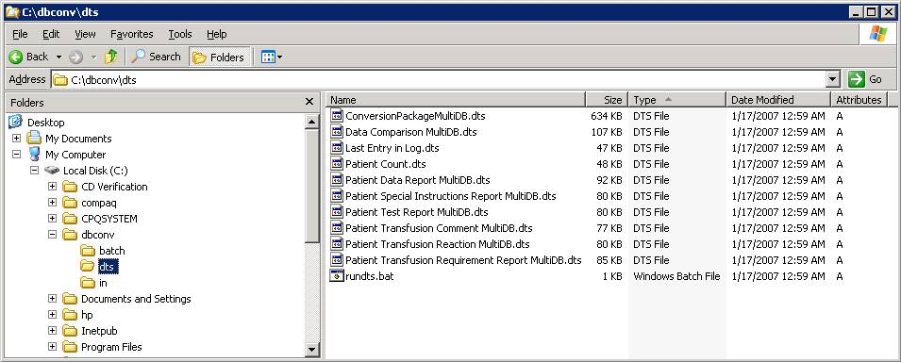
This page intentionally left blank.

Appendix B: Example of DCL Command Procedure
This is an example of the display from the execution of the DCL command procedure.
Figure 35: Example of DCL Command Execution
$ @VBECSBATCH
I.P. Address: 10.3.21.27
Username: VHA99\VHAnnnNTNAME
Password will not echo to screen
Password:

Starting: 4-APR-2007 09:49:19.31

220-Microsoft FTP Service
220 VBECS Server. Federal property. Don't tamper.
Connected to vhaishmul6.vha.med.va.gov.
331 Password required for DBCONV.
230 User DBCONV logged in.
200 Type set to A.
200 PORT command successful.
local: $1$DGA2:[TEMP]DBCONV.INI;1 remote: dbconv.ini
272750 bytes sent in 00:00:00.01 seconds (48 bytes/s)
200 PORT command successful.
150 Opening ASCII mode data connection for vbec63_ai.txt.
226 Transfer complete.
local: $1$DGA2:[TEMP]VBEC63_AI.TXT;1 remote: vbec63_ai.txt
1479 bytes sent in 00:00:00.00 seconds (1444.34 Kbytes/s)
200 PORT command successful.
150 Opening ASCII mode data connection for vbec63_antia.txt.
226 Transfer complete.
local: $1$DGA2:[TEMP]VBEC63_ANTIA.TXT;1 remote: vbec63_antia.txt
118 bytes sent in 00:00:00.00 seconds (115.23 Kbytes/s)
200 PORT command successful.
150 Opening ASCII mode data connection for vbec63_antip.txt.
226 Transfer complete.
local: $1$DGA2:[TEMP]VBEC63_ANTIP.TXT;1 remote: vbec63_antip.txt
48 bytes sent in 00:00:00.00 seconds (46.88 Kbytes/s)
200 PORT command successful.
150 Opening ASCII mode data connection for vbec63_bbc.txt.
226 Transfer complete.
local: $1$DGA2:[TEMP]VBEC63_BBC.TXT;1 remote: vbec63_bbc.txt
5975 bytes sent in 00:00:00.00 seconds (5834.96 Kbytes/s)
200 PORT command successful.
150 Opening ASCII mode data connection for vbec63_pat.txt.
226 Transfer complete.
local: $1$DGA2:[TEMP]VBEC63_PAT.TXT;1 remote: vbec63_pat.txt
272750 bytes sent in 00:00:00.03 seconds (7198.85 Kbytes/s)
200 PORT command successful.
150 Opening ASCII mode data connection for vbec63_trc.txt.
226 Transfer complete.
local: $1$DGA2:[TEMP]VBEC63_TRC.TXT;1 remote: vbec63_trc.txt
57 bytes sent in 00:00:00.00 seconds (55.66 Kbytes/s)
200 PORT command successful.
150 Opening ASCII mode data connection for vbec63_trd.txt.
226 Transfer complete.
local: $1$DGA2:[TEMP]VBEC63_TRD.TXT;1 remote: vbec63_trd.txt
34 bytes sent in 00:00:00.00 seconds (33.20 Kbytes/s)
200 PORT command successful.
150 Opening ASCII mode data connection for vbec_finis.txt.
226 Transfer complete.
local: $1$DGA2:[TEMP]VBEC_FINIS.TXT;1 remote: vbec_finis.txt
299344 bytes sent in 00:00:00.03 seconds (8597.89 Kbytes/s)
221
Completed: 4-APR-2007 09:49:21.02

Appendix C: Example of DTSRUN
Run the DTS Package. The DTSRUN command will extract the data to be converted from the VistA datafiles and place it in text files for conversion to VBECS (Figure 36).
Figure 36: Run the DTS Package
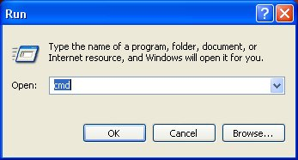
Figure 37: Example of DTSRUN Execution
Microsoft Windows XP [Version 5.1.2600]
(C) Copyright 1985-2001 Microsoft Corp.

C:\DBConv\DTS>dtsrun /f conversionpackagemultidb.dts
DTSRun: Loading...
DTSRun: Executing...
DTSRun OnStart: DTSStep_DTSDynamicPropertiesTask_1
DTSRun OnFinish: DTSStep_DTSDynamicPropertiesTask_1
DTSRun OnStart: DTSStep_DTSCreateProcessTask_1
DTSRun OnFinish: DTSStep_DTSCreateProcessTask_1
DTSRun OnStart: DTSStep_DTSCreateProcessTask_2
1 file(s) copied.
DTSRun OnFinish: DTSStep_DTSCreateProcessTask_2
DTSRun OnStart: DTSStep_DTSExecuteSQLTask_17
DTSRun OnFinish: DTSStep_DTSExecuteSQLTask_17
DTSRun OnStart: DTSStep_DTSExecuteSQLTask_1
DTSRun OnFinish: DTSStep_DTSExecuteSQLTask_1
DTSRun OnStart: DTSStep_DTSExecuteSQLTask_2
DTSRun OnFinish: DTSStep_DTSExecuteSQLTask_2
DTSRun OnStart: DTSStep_DTSExecuteSQLTask_3
DTSRun OnFinish: DTSStep_DTSExecuteSQLTask_3
DTSRun OnStart: DTSStep_DTSExecuteSQLTask_4
DTSRun OnFinish: DTSStep_DTSExecuteSQLTask_4
DTSRun OnStart: DTSStep_DTSExecuteSQLTask_5
DTSRun OnFinish: DTSStep_DTSExecuteSQLTask_5
DTSRun OnStart: DTSStep_DTSExecuteSQLTask_6
DTSRun OnFinish: DTSStep_DTSExecuteSQLTask_6
DTSRun OnStart: DTSStep_DTSExecuteSQLTask_7
DTSRun OnFinish: DTSStep_DTSExecuteSQLTask_7
DTSRun OnStart: DTSStep_DTSExecuteSQLTask_8
DTSRun OnFinish: DTSStep_DTSExecuteSQLTask_8
DTSRun OnStart: DTSStep_DTSExecuteSQLTask_9
DTSRun OnFinish: DTSStep_DTSExecuteSQLTask_9
DTSRun OnStart: DTSStep_DTSExecuteSQLTask_10
DTSRun OnFinish: DTSStep_DTSExecuteSQLTask_10
DTSRun OnStart: DTSStep_DTSExecuteSQLTask_11
DTSRun OnFinish: DTSStep_DTSExecuteSQLTask_11
DTSRun OnStart: DTSStep_DTSExecuteSQLTask_12
DTSRun OnFinish: DTSStep_DTSExecuteSQLTask_12
DTSRun OnStart: DTSStep_DTSExecuteSQLTask_13
DTSRun OnFinish: DTSStep_DTSExecuteSQLTask_13
DTSRun OnStart: DTSStep_DTSExecuteSQLTask_14
DTSRun OnFinish: DTSStep_DTSExecuteSQLTask_14
DTSRun OnStart: DTSStep_DTSExecuteSQLTask_15
DTSRun OnFinish: DTSStep_DTSExecuteSQLTask_15
DTSRun OnStart: DTSStep_DTSExecuteSQLTask_16
DTSRun OnFinish: DTSStep_DTSExecuteSQLTask_16
DTSRun OnStart: DTSStep_DTSExecuteSQLTask_18
DTSRun OnFinish: DTSStep_DTSExecuteSQLTask_18
DTSRun OnStart: DTSStep_DTSExecutePackageTask_1
DTSRun OnProgress: DTSStep_DTSExecutePackageTask_1; Copy Data from Results to Results Step: 1000 Rows have been transformed or copied.; PercentComplete = 0; ProgressCount = 1000
DTSRun OnProgress: DTSStep_DTSExecutePackageTask_1; Copy Data from Results to Results Step: 2000 Rows have been transformed or copied.; PercentComplete = 0; ProgressCount = 2000
DTSRun OnProgress: DTSStep_DTSExecutePackageTask_1; Copy Data from Results to Results Step: 3000 Rows have been transformed or copied.; PercentComplete = 0; ProgressCount = 3000
DTSRun OnProgress: DTSStep_DTSExecutePackageTask_1; Copy Data from Results to Results Step: 4000 Rows have been transformed or copied.; PercentComplete = 0; ProgressCount = 4000
DTSRun OnProgress: DTSStep_DTSExecutePackageTask_1; Copy Data from Results to Results Step: 5000 Rows have been transformed or copied.; PercentComplete = 0; ProgressCount = 5000
DTSRun OnProgress: DTSStep_DTSExecutePackageTask_1; Copy Data from Results to Results Step: 6000 Rows have been transformed or copied.; PercentComplete = 0; ProgressCount = 6000
DTSRun OnProgress: DTSStep_DTSExecutePackageTask_1; Copy Data from Results to Results Step: 7000 Rows have been transformed or copied.; PercentComplete = 0; ProgressCount = 7000
DTSRun OnProgress: DTSStep_DTSExecutePackageTask_1; Copy Data from Results to Results Step: 8000 Rows have been transformed or copied.; PercentComplete = 0; ProgressCount = 8000
DTSRun OnProgress: DTSStep_DTSExecutePackageTask_1; Copy Data from Results to Results Step: 9000 Rows have been transformed or copied.; PercentComplete = 0; ProgressCount = 9000
DTSRun OnProgress: DTSStep_DTSExecutePackageTask_1; Copy Data from Results to Results Step: 10000 Rows have been transformed or copied.; PercentComplete = 0; ProgressCount = 10000
DTSRun OnProgress: DTSStep_DTSExecutePackageTask_1; Copy Data from Results to Results Step: 11000 Rows have been transformed or copied.; PercentComplete = 0; ProgressCount = 11000
DTSRun OnProgress: DTSStep_DTSExecutePackageTask_1; Copy Data from Results to Results Step: 12000 Rows have been transformed or copied.; PercentComplete = 0; ProgressCount = 12000
DTSRun OnProgress: DTSStep_DTSExecutePackageTask_1; Copy Data from Results to Results Step: 13000 Rows have been transformed or copied.; PercentComplete = 0; ProgressCount = 13000
DTSRun OnProgress: DTSStep_DTSExecutePackageTask_1; Copy Data from Results to Results Step: 14000 Rows have been transformed or copied.; PercentComplete = 0; ProgressCount = 14000
DTSRun OnProgress: DTSStep_DTSExecutePackageTask_1; Copy Data from Results to Results Step: 15000 Rows have been transformed or copied.; PercentComplete = 0; ProgressCount = 15000
DTSRun OnProgress: DTSStep_DTSExecutePackageTask_1; Copy Data from Results to Results Step: 16000 Rows have been transformed or copied.; PercentComplete = 0; ProgressCount = 16000
DTSRun OnProgress: DTSStep_DTSExecutePackageTask_1; Copy Data from Results to Results Step: 17000 Rows have been transformed or copied.; PercentComplete = 0; ProgressCount = 17000
DTSRun OnProgress: DTSStep_DTSExecutePackageTask_1; Copy Data from Results to Results Step: 18000 Rows have been transformed or copied.; PercentComplete = 0; ProgressCount = 18000
DTSRun OnProgress: DTSStep_DTSExecutePackageTask_1; Copy Data from Results to Results Step: 19000 Rows have been transformed or copied.; PercentComplete = 0; ProgressCount = 19000
DTSRun OnProgress: DTSStep_DTSExecutePackageTask_1; Copy Data from Results to Results Step: 20000 Rows have been transformed or copied.; PercentComplete = 0; ProgressCount = 20000
DTSRun OnProgress: DTSStep_DTSExecutePackageTask_1; Copy Data from Results to Results Step: 21000 Rows have been transformed or copied.; PercentComplete = 0; ProgressCount = 21000
DTSRun OnProgress: DTSStep_DTSExecutePackageTask_1; Copy Data from Results to Results Step: 22000 Rows have been transformed or copied.; PercentComplete = 0; ProgressCount = 22000
DTSRun OnProgress: DTSStep_DTSExecutePackageTask_1; Copy Data from Results to Results Step: 23000 Rows have been transformed or copied.; PercentComplete = 0; ProgressCount = 23000
DTSRun OnProgress: DTSStep_DTSExecutePackageTask_1; Copy Data from Results to Results Step: 24000 Rows have been transformed or copied.; PercentComplete = 0; ProgressCount = 24000
DTSRun OnProgress: DTSStep_DTSExecutePackageTask_1; Copy Data from Results to Results Step: 25000 Rows have been transformed or copied.; PercentComplete = 0; ProgressCount = 25000
DTSRun OnProgress: DTSStep_DTSExecutePackageTask_1; Copy Data from Results to Results Step: 26000 Rows have been transformed or copied.; PercentComplete = 0; ProgressCount = 26000
DTSRun OnProgress: DTSStep_DTSExecutePackageTask_1; Copy Data from Results to Results Step: 27000 Rows have been transformed or copied.; PercentComplete = 0; ProgressCount = 27000
DTSRun OnProgress: DTSStep_DTSExecutePackageTask_1; Copy Data from Results to Results Step: 27546 Rows have been transformed or copied.; PercentComplete = 0; ProgressCount = 27546
DTSRun OnFinish: DTSStep_DTSExecutePackageTask_1
DTSRun OnStart: DTSStep_DTSExecutePackageTask_2
DTSRun OnProgress: DTSStep_DTSExecutePackageTask_2; Copy Data from Results to Results Step: 1000 Rows have been transformed or copied.; PercentComplete = 0; ProgressCount = 1000
DTSRun OnProgress: DTSStep_DTSExecutePackageTask_2; Copy Data from Results to Results Step: 1966 Rows have been transformed or copied.; PercentComplete = 0; ProgressCount = 1966
DTSRun OnFinish: DTSStep_DTSExecutePackageTask_2
DTSRun OnStart: DTSStep_DTSExecutePackageTask_3
DTSRun OnProgress: DTSStep_DTSExecutePackageTask_3; Copy Data from Results to Results Step: 0 Rows have been transformed or copied.; PercentComplete = 0; ProgressCount = 0
DTSRun OnFinish: DTSStep_DTSExecutePackageTask_3
DTSRun OnStart: DTSStep_DTSExecutePackageTask_4
DTSRun OnProgress: DTSStep_DTSExecutePackageTask_4; Copy Data from Results to Results Step: 4 Rows have been transformed or copied.; PercentComplete = 0; ProgressCount = 4
DTSRun OnFinish: DTSStep_DTSExecutePackageTask_4
DTSRun OnStart: DTSStep_DTSExecutePackageTask_5
DTSRun OnProgress: DTSStep_DTSExecutePackageTask_5; Copy Data from Results to Results Step: 135 Rows have been transformed or copied.; PercentComplete = 0; ProgressCount = 135
DTSRun OnFinish: DTSStep_DTSExecutePackageTask_5
DTSRun OnStart: DTSStep_DTSExecutePackageTask_6
DTSRun OnProgress: DTSStep_DTSExecutePackageTask_6; Copy Data from Results to Results Step: 306 Rows have been transformed or copied.; PercentComplete = 0; ProgressCount = 306
DTSRun OnFinish: DTSStep_DTSExecutePackageTask_6
DTSRun OnStart: DTSStep_DTSExecutePackageTask_7
DTSRun OnProgress: DTSStep_DTSExecutePackageTask_7; Copy Data from TempVBECSDataComparison to TempVBECSDataComparison Step: 1 Rows have been transformed or copied.; PercentComplete = 0; ProgressCount = 1
DTSRun OnFinish: DTSStep_DTSExecutePackageTask_7
DTSRun OnStart: DTSStep_DTSExecuteSQLTask_19
DTSRun OnFinish: DTSStep_DTSExecuteSQLTask_19
DTSRun OnStart: DTSStep_DTSExecutePackageTask_9
DTSRun OnFinish: DTSStep_DTSExecutePackageTask_9
DTSRun: Package execution complete.

C:\DBConv\DTS>
Figure 38: Successful Conversion
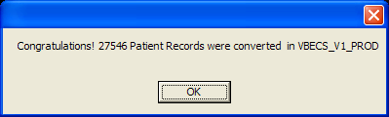

Appendix D: Database Table Information
The TempDataConversionVistARecordDetail table will be created with the data definitions in Table 2.
Table 2: Data Conversion VistA Record Detail Table Data Definitions
Column | Data Type
LRDFN | Int
DFN | Int
LastName | Int
FirstName | Int
MiddleName | Int
NameSuffix | Int
Sex | Int
DOB | Int
SSN | Int
ICN | Int
ABO | Int
RHFactor | Int
AntigensPresentQuantity | Int
AntigensPresentCommentQuantity | Int
AntigensPresentCommentLength | Int
AntigensAbsentQuantity | Int
AntigensAbsentCommentQuantity | Int
AntigensAbsentCommentLength | Int
AntibodiesIdentifiedQuantity | Int
AntibodiesIdentifiedCommentQuantity | Int
AntibodiesIdentifiedLength | Int
TransfusionReactionDateQuantity | Int
TransfusionReactionQuantity | Int
TransfusionReactionCommentQuantity | Int
TransfusionReactionCommentLength | Int
BloodBankCommentsQuantity | Int
BloodBankCommentsLength | Int

The TempDataConversionVistARecordTotals table will be created with the data definitions in Table 3.
Table 3: Data Conversion VistA Record Totals Table Data Definitions
Column | Data Type
LRDFN | Int
DFN | Int
LastName | Int
FirstName | Int
MiddleName | Int
NameSuffix | Int
Sex | Int
DOB | Int
SSN | Int
ICN | Int
ABO | Int
RHFactor | Int
AntigensPresentQuantity | Int
AntigensPresentCommentQuantity | Int
AntigensPresentCommentLength | Int
AntigensAbsentQuantity | Int
AntigensAbsentCommentQuantity | Int
AntigensAbsentCommentLength | Int
AntibodiesIdentifiedQuantity | Int
AntibodiesIdentifiedCommentQuantity | Int
AntibodiesIdentifiedLength | Int
TransfusionReactionDateQuantity | Int
TransfusionReactionQuantity | Int
TransfusionReactionCommentQuantity | Int
TransfusionReactionCommentLength | Int
BloodBankCommentsQuantity | Int
BloodBankCommentsLength | Int

The final record in the vbec63_finis.txt file contains the totals for all records extracted from the VistA database. This record (both the LRDFN and DFN will be “0” for this record in the TempDataConversionVistARecordDetails table) will be used to populate the TempDataConversionVBECSRecordTotals table and then be removed from the TempDataConversionVBECSRecordDetails table.
The TempDataConversionVBECSRecordDetail table will be created with the data definitions in Table 4.
Table 4: Data Conversion VBECS Record Details Table Data Definitions
Column | Data Type
LRDFN | Int
DFN | Int
LastName | Int
FirstName | Int
MiddleName | Int
NameSuffix | Int
Sex | Int
DOB | Int
SSN | Int
ICN | Int
ABO | Int
RHFactor | Int
AntigensPresentQuantity | Int
AntigensPresentCommentQuantity | Int
AntigensPresentCommentLength | Int
AntigensAbsentQuantity | Int
AntigensAbsentCommentQuantity | Int
AntigensAbsentCommentLength | Int
AntibodiesIdentifiedQuantity | Int
AntibodiesIdentifiedCommentQuantity | Int
AntibodiesIdentifiedLength | Int
TransfusionReactionDateQuantity | Int
TransfusionReactionQuantity | Int
TransfusionReactionCommentQuantity | Int
TransfusionReactionCommentLength | Int
BloodBankCommentsQuantity | Int
BloodBankCommentsLength | Int

The TempDataConversionVBECSRecordDetail table will be populated from the sources in Table 5.
Table 5: Data Conversion VBECS Record Details Source SQL Tables
Destination Column | Source Column | Source Table
LRDFN | PtntLRDFN | TempVBECPatient
DFN | VistaPatientID | TempVBECPatient
LastName | PatientLastName | TempVBECPatient
FirstName | PatientFirstName | TempVBECPatient
MiddleName | PatientMiddleName | TempVBECPatient
NameSuffix | PatientNameSuffix | TempVBECPatient
Sex | PatientSexCode | TempVBECPatient
DOB | PatientDOB | TempVBECPatient
SSN | PatientSSN | TempVBECPatient
ICN | PatientICN | TempVBECPatient
ABO | BloodTypeCode | TempVBECPatient
RHFactor | RHFactorCode | TempVBECPatient
AntigensPresentQuantity | AntigenPresentCode | TempPatientAntigenPresent
AntigensPresentCommentQuantity | AntigenPresentComment | TempPatientAntigenPresent
AntigensPresentCommentLength | AntigenPresentComment | TempPatientAntigenPresent
AntigensAbsentQuantity | AntigenAbsentCode | TempPatientAntigenAbsent
AntigensAbsentCommentQuantity | AntigenAbsentComment | TempPatientAntigenAbsent
AntigensAbsentCommentLength | AntigenAbsentComment | TempPatientAntigenAbsent
AntibodiesIdentifiedQuantity | AntibodyIdentifiedCode | TempPatientAntibodyIdentified
AntibodiesIdentifiedCommentQuantity | AntibodyIdentifiedComment | TempPatientAntibodyIdentified
AntibodiesIdentifiedLength | AntibodyIdentifiedComment | TempPatientAntibodyIdentified
TransfusionReactionDateQuantity | TransfusionReactionDate | TempPatientTransfusionReactionDate
TransfusionReactionQuantity | TransfusionReactionTypeGUID | TempPatientTransfusionReactionDate
BloodBankCommentsQuantity | Comment | TempVBECSSpecialInstructions
BloodBankCommentsLength | Comment | TempVBECSSpecialInstructions

The TempDataConversionVBECSRecordTotal table will be created with the data definitions in Table 6.
Table 6: Data Conversion VBECS Record Totals Table Data Definitions
Column | Data Type
LRDFN | Int
DFN | Int
LastName | Int
FirstName | Int
MiddleName | Int
NameSuffix | Int
Sex | Int
DOB | Int
SSN | Int
ICN | Int
ABO | Int
RHFactor | Int
AntigensPresentQuantity | Int
AntigensPresentCommentQuantity | Int
AntigensPresentCommentLength | Int
AntigensAbsentQuantity | Int
AntigensAbsentCommentQuantity | Int
AntigensAbsentCommentLength | Int
AntibodiesIdentifiedQuantity | Int
AntibodiesIdentifiedCommentQuantity | Int
AntibodiesIdentifiedLength | Int
TransfusionReactionDateQuantity | Int
TransfusionReactionQuantity | Int
TransfusionReactionCommentQuantity | Int
TransfusionReactionCommentLength | Int
BloodBankCommentsQuantity | Int
BloodBankCommentsLength | Int

The TempDataConversionVBECSRecordTotal table will be populated from the sources in Table 7.
Table 7: Data Conversion VBECS Record Totals Source SQL Tables
Destination Column | Source Column | Source Table
LRDFN | PtntLRDFN | TempVBECPatient
DFN | VistaPatientID | TempVBECPatient
LastName | PatientLastName | TempVBECPatient
FirstName | PatientFirstName | TempVBECPatient
MiddleName | PatientMiddleName | TempVBECPatient
NameSuffix | PatientNameSuffix | TempVBECPatient
Sex | PatientSexCode | TempVBECPatient
DOB | PatientDOB | TempVBECPatient
SSN | PatientSSN | TempVBECPatient
ICN | PatientICN | TempVBECPatient
ABO | BloodTypeCode | TempVBECPatient
RHFactor | RHFactorCode | TempVBECPatient
AntigensPresentQuantity | AntigenPresentCode | TempPatientAntigenPresent
AntigensPresentCommentQuantity | AntigenPresentComment | TempPatientAntigenPresent
AntigensPresentCommentLength | AntigenPresentComment | TempPatientAntigenPresent
AntigensAbsentQuantity | AntigenAbsentCode | TempPatientAntigenAbsent
AntigensAbsentCommentQuantity | AntigenAbsentComment | TempPatientAntigenAbsent
AntigensAbsentCommentLength | AntigenAbsentComment | TempPatientAntigenAbsent
AntibodiesIdentifiedQuantity | AntibodyIdentifiedCode | TempPatientAntibodyIdentified
AntibodiesIdentifiedCommentQuantity | AntibodyIdentifiedComment | TempPatientAntibodyIdentified
AntibodiesIdentifiedLength | AntibodyIdentifiedComment | TempPatientAntibodyIdentified
TransfusionReactionDateQuantity | TransfusionReactionDate | TempPatientTransfusionReactionDate
TransfusionReactionQuantity | TransfusionReactionTypeGUID | TempPatientTransfusionReactionDate
BloodBankCommentsQuantity | Comment | TempVBECSSpecialInstructions
BloodBankCommentsLength | Comment | TempVBECSSpecialInstructions

The columns in the TempDataConversionVBECSRecordDetail and the TempDataConversionVistARecordDetail tables will be used to create a report detailing differences between the two as shown in Table 8.
Table 8: Record Detail Comparison Report Table Data Definitions
TempDataConversionVBECSRecordDetail | TempDataConversionVISTARecordDetail
LRDFN | LRDFN
LastName | LastName
FirstName | FirstName
MiddleName | MiddleName
NameSuffix | NameSuffix
Sex | Sex
DOB | DOB
SSN | SSN
ICN | ICN
ABO | ABO
RHFactor | RHFactor
AntigensPresentQuantity | AntigensPresentQuantity
AntigensPresentCommentQuantity | AntigensPresentCommentQuantity
AntigensPresentCommentLength | AntigensPresentCommentLength
AntigensAbsentQuantity | AntigensAbsentQuantity
AntigensAbsentCommentQuantity | AntigensAbsentCommentQuantity
AntigensAbsentCommentLength | AntigensAbsentCommentLength
AntibodiesIdentifiedQuantity | AntibodiesIdentifiedQuantity
AntibodiesIdentifiedCommentQuantity | AntibodiesIdentifiedCommentQuantity
AntibodiesIdentifiedLength | AntibodiesIdentifiedLength
TransfusionReactionDateQuantity | TransfusionReactionDateQuantity
TransfusionReactionQuantity | TransfusionReactionQuantity
TransfusionReactionCommentQuantity | TransfusionReactionCommentQuantity
TransfusionReactionCommentLength | TransfusionReactionCommentLength
BloodBankCommentsLength | BloodBankCommentsLength

The TempVBECSDataComparison table will be created with the data definitions in Table 9.
Table 9: VBECS Data Comparison Table Data Definitions
Column | Data Type
LastNameMismatch | varchar(50)
FirstNameMisMatch | varchar(50)
MiddleNameMisMatch | varchar(50)
NameSuffixMisMatch | varchar(50)
SexMisMatch | varchar(50)
DOBMisMatch | varchar(50)
SSNMisMatch | varchar(50)
ICNMisMatch | varchar(50)
ABOMisMatch | varchar(50)
RHFactorMisMatch | varchar(50)
AntigensPresentQuantityMisMatch | varchar(50)
AntigensPresentCommentQuantityMisMatch | varchar(50)
AntigensPresentCommentLengthMisMatch | varchar(50)
AntigensAbsentQuantityMisMatch | varchar(50)
AntigensAbsentCommentQuantityMismatch | varchar(50)
AntigensAbsentCommentLengthMisMatch | varchar(50)
AntibodiesIdentifiedQuantityMisMatch | varchar(50)
AntibodiesIdentifiedCommentQuantityMisMatch | varchar(50)
AntibodiesIdentifiedLengthMisMatch | varchar(50)
TransfusionReactionDateQuantityMisMatch | varchar(50)
TransfusionReactionQuantityMisMatch | varchar(50)
TransfusionReactionCommentQuantityMisMatch | varchar(50)
TransfusionReactionCommentLengthMisMatch | varchar(50)
BloodBankCommentsLengthMisMatch | varchar(50)

Table 10 will list differences between the TempDataConversionVBECSRecordDetail and the TempDataConversionVistARecordDetail tables. This example was truncated for clarity: each column in the TempVBECSDataComparison will be populated.
Table 10: Example of VBECS Data Comparison Table
LRDFN | MiddleNameMisMatch | AntigensPresentQuantityMisMatch | AntibodiesIdentifiedLengthMisMatch | TransfusionReactionQuantityMisMatch
1451 | None | 0 <VBECS--VISTA> 3 | None | None
1278 | None | None | None | 7 <VBECS--VISTA> 0
15094 | None | None | 33 <VBECS--VISTA> 0 | None
9167 | 1 <VBECS--VISTA> 0 | None | None | None

Appendix E: Example of C:\DBConv Excel File Location
Example of the Contents of the C:\DBCONV Folder on the VBECS Server. These files will be used during the data validation and were created by the DTSRUN shown in Appendix C: Example of DTSRUN (Figure 39).
Figure 39: Example of C:\DBConv Excel File Location
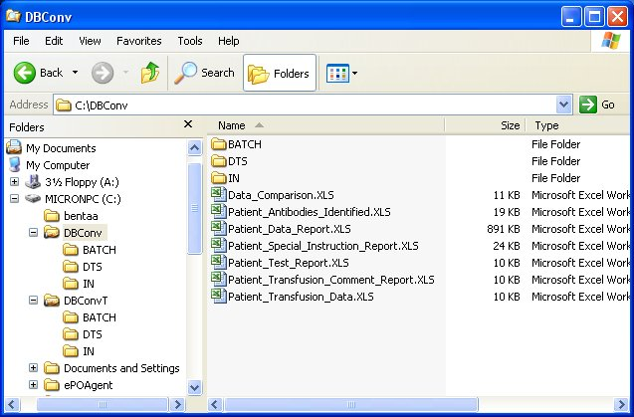
This page intentionally left blank.

Index

A
Accessing the System 5
Appendices 41
Application Architecture 3
C
Customer Support 4
D
Digital Command Language 13
Disable FTP Service after Test Account Conversion 29
E
Enable FTP Service for Production Account Conversion 30
Execute the DCL Command Procedure 14
Execute the DTS Package 14
Exit the VBECS System 10
Exit VistA 11
G
Glossary 39
H
How This Installation and User Guide Is Organized 3
I
Install the DCL Command Procedure 13
Install the LR*5.2*335 KIDS Build 13
Install the VBECS Data Conversion Data Transformation Services Package 14
Installation Procedure 13
Introduction 1
K
Known Defects and Anomalies 37
L
Log Into the VBECS System 5
Log Into VistA 8
M
Microsoft Excel 13
Microsoft SQL Server Enterprise Manager 13
O
Orientation 3
P
Post-Installation Procedure 29
Prerequisites 3
Problems? 4
R
Related Manuals and Materials 1
Remove FTP Service 32
Retrieve Excel Files from the VBECS System 15
S
Software Basics 5
SQL Server Enterprise Manager 13
T
Target Audience 5
Tools 13
Digital Equipment Corporation's DCL 13
Microsoft Excel 13
Microsoft SQL Server Enterprise Manager 13
SQL Server Enterprise Manager 13
VA FileMan 13
Troubleshooting See Problems?
U
Using the Software 5
V
VA FileMan 13
Validate the Data 19
Verify Antibodies 26
Verify Antigens 27
Verify Transfusion Reaction Type 28
Verifying the Conversion 19

This is the last page of Blood Bank Pre-Implementation Data Validation, Mapping, and Conversion Installation and User Guide.

There are differences in terminology between VistA and VBECS: VistA uses “log on” and “logon,” and VBECS uses “log in” and “login.” Both terms are used throughout this guide.
This is the patient name. The internal entry number of the patient record may be entered in lieu of the patient name.
This is the patient name. The internal entry number of the patient record may be entered in lieu of the patient name.
This is the internal entry number of the patient record. The patient name may be entered in lieu of the internal entry number of the patient record.
This is the internal entry number of the patient record. The patient name may be entered in lieu of the internal entry number of the patient record.

